**Assignment-1 A Prashanth S**

**19MID0020**

**Question**

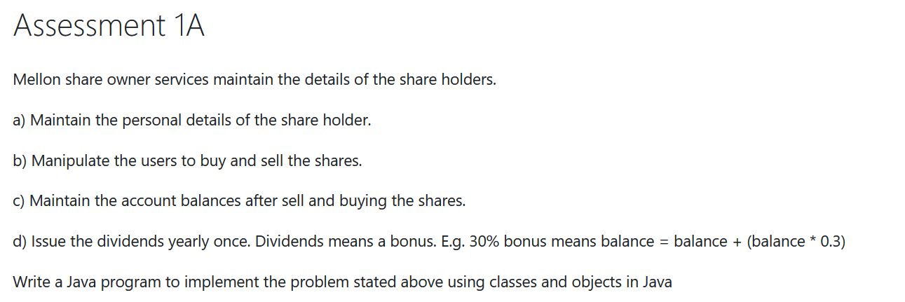  
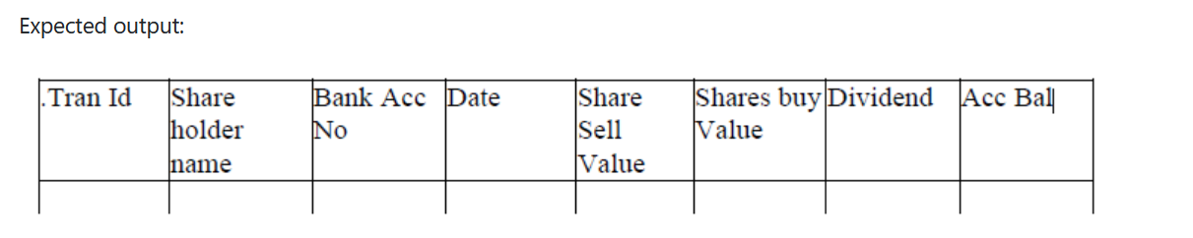

**Melon Class**

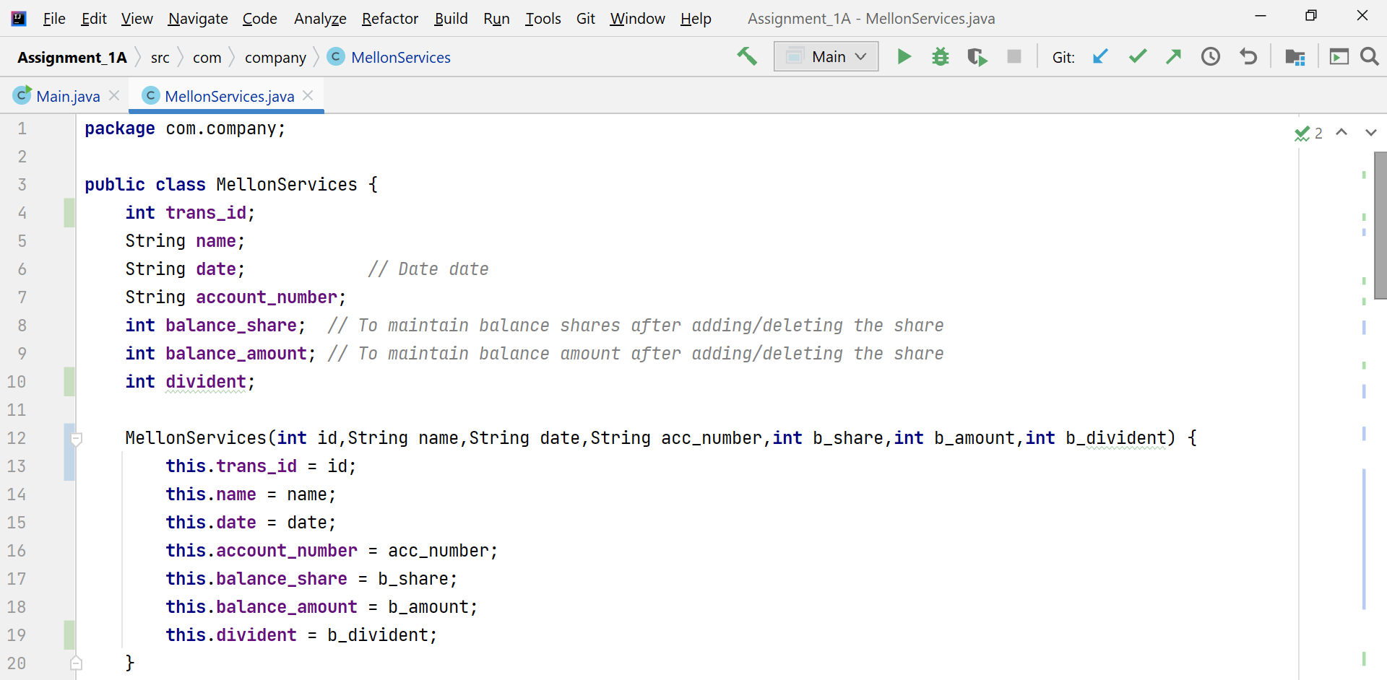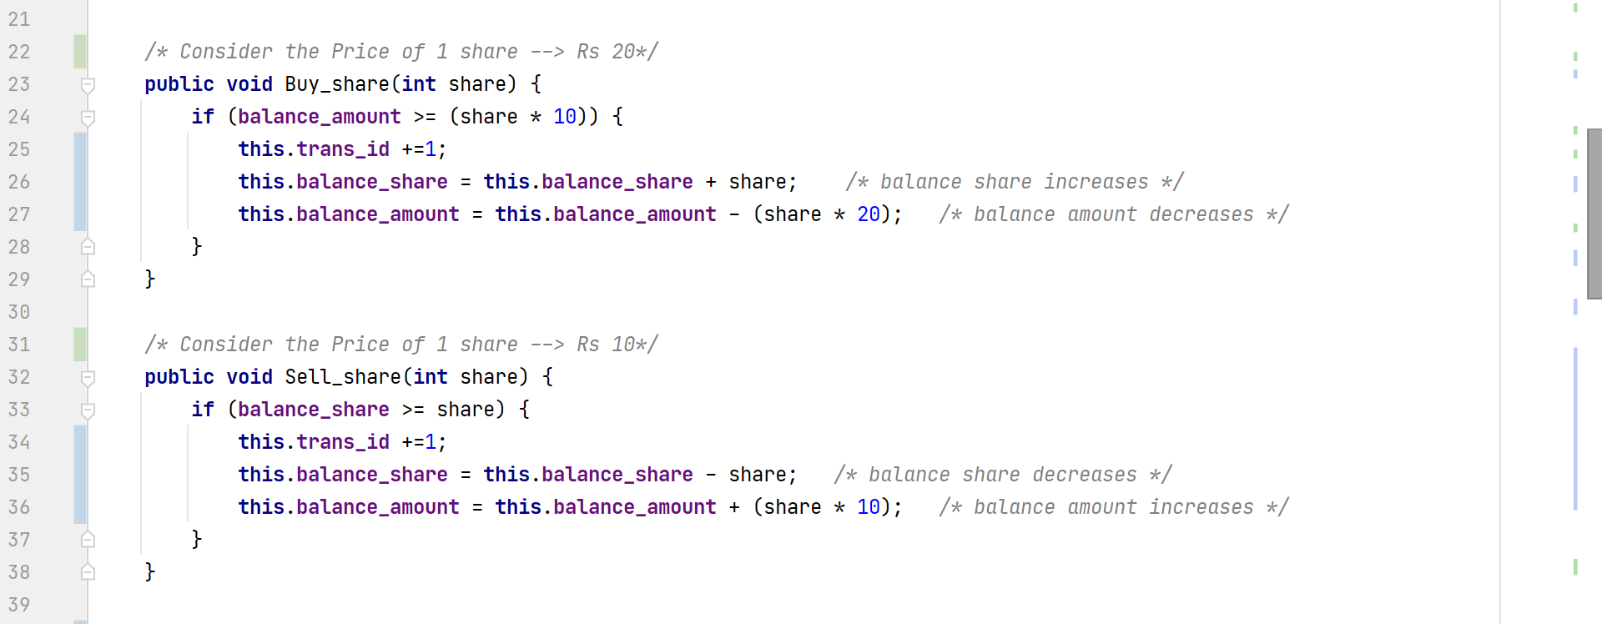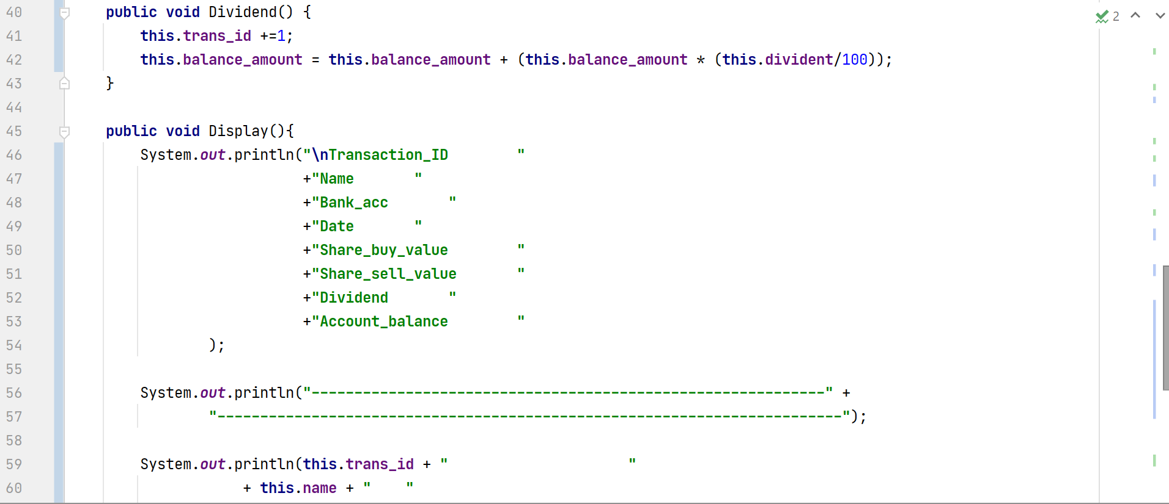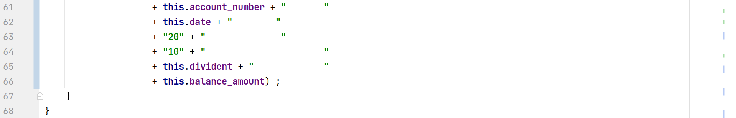

**Main method**

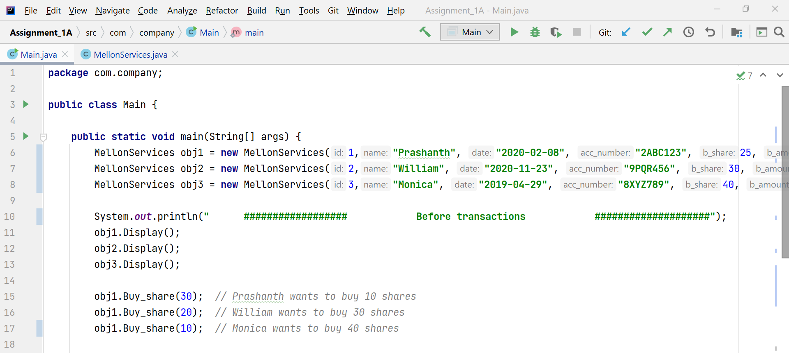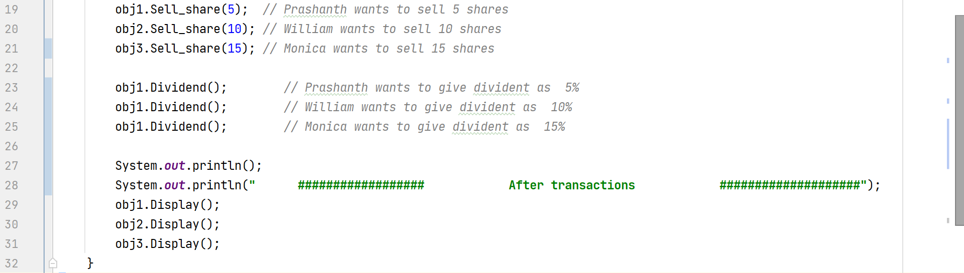

**Output**

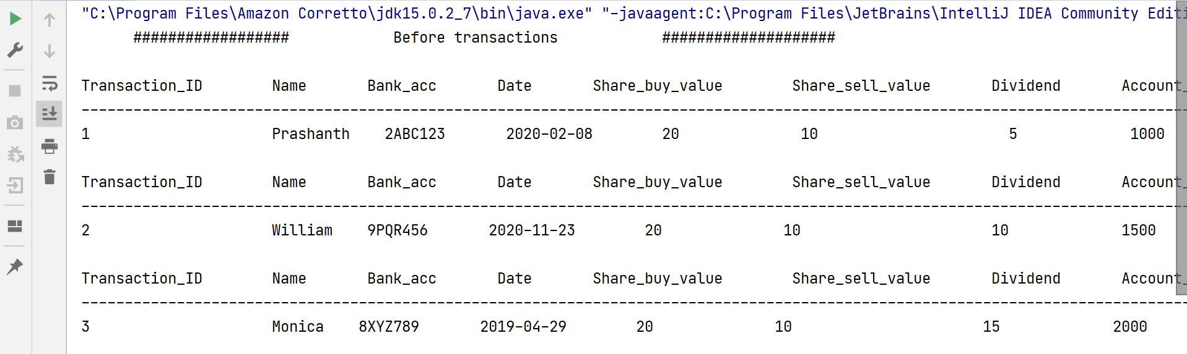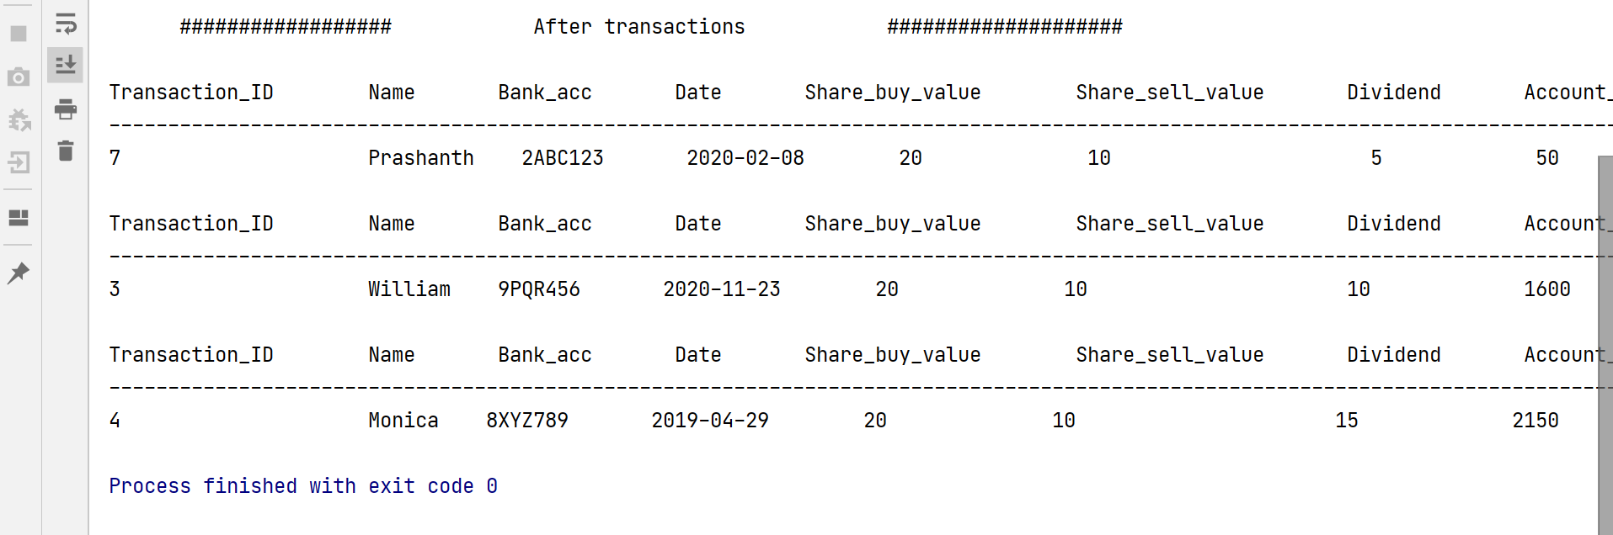

**Melon Class**

**package** com.company;  
  
**public class** MellonServices {  
 **int trans_id**;  
 String **name**;  
 String **date**; *// Date date* String **account_number**;  
 **int balance_share**; *// To maintain balance shares after adding/deleting the share* **int balance_amount**; *// To maintain balance amount after adding/deleting the share* **int divident**;  
  
 MellonServices(**int** id,String name,String date,String acc_number,**int** b_share,**int** b_amount,**int** b_divident) {  
 **this**.**trans_id** = id;  
 **this**.**name** = name;  
 **this**.**date** = date;  
 **this**.**account_number** = acc_number;  
 **this**.**balance_share** = b_share;  
 **this**.**balance_amount** = b_amount;  
 **this**.**divident** = b_divident;  
 }  
  
 */* Consider the Price of 1 share --> Rs 20*/* **public void** Buy_share(**int** share) {  
 **if** (**balance_amount** >= (share * 10)) {  
 **this**.**trans_id** +=1;  
 **this**.**balance_share** = **this**.**balance_share** + share; */* balance share increases */* **this**.**balance_amount** = **this**.**balance_amount** - (share * 20); */* balance amount decreases */* }  
 }  
  
 */* Consider the Price of 1 share --> Rs 10*/* **public void** Sell_share(**int** share) {  
 **if** (**balance_share** >= share) {  
 **this**.**trans_id** +=1;  
 **this**.**balance_share** = **this**.**balance_share** - share; */* balance share decreases */* **this**.**balance_amount** = **this**.**balance_amount** + (share * 10); */* balance amount increases */* }  
 }  
  
 **public void** Dividend() {  
 **this**.**trans_id** +=1;  
 **this**.**balance_amount** = **this**.**balance_amount** + (**this**.**balance_amount** * (**this**.**divident**/100));  
 }  
  
 **public void** Display(){  
 System.***out***.println(**"\nTransaction_ID "** +**"Name "** +**"Bank_acc "** +**"Date "** +**"Share_buy_value "** +**"Share_sell_value "** +**"Dividend "** +**"Account_balance "** );  
  
 System.***out***.println(**"------------------------------------------------------------"** +  
 **"-------------------------------------------------------------------------"**);  
  
 System.***out***.println(**this**.**trans_id** + **" "** + **this**.**name** + **" "** + **this**.**account_number** + **" "** + **this**.**date** + **" "** + **"20"** + **" "** + **"10"** + **" "** + **this**.**divident** + **" "** + **this**.**balance_amount**) ;  
 }  
}

**Main method**

**package** com.company;  
  
**public class** Main {  
  
 **public static void** main(String[] args) {  
 MellonServices obj1 = **new** MellonServices(1,**"Prashanth"**, **"2020-02-08"**, **"2ABC123"**, 25, 1000,5);  
 MellonServices obj2 = **new** MellonServices(2,**"William"**, **"2020-11-23"**, **"9PQR456"**, 30, 1500,10);  
 MellonServices obj3 = **new** MellonServices(3,**"Monica"**, **"2019-04-29"**, **"8XYZ789"**, 40, 2000,15);  
  
 System.***out***.println(**" ################## Before transactions ####################"**);  
 obj1.Display();  
 obj2.Display();  
 obj3.Display();  
  
 obj1.Buy_share(30); *// Prashanth wants to buy 10 shares* obj1.Buy_share(20); *// William wants to buy 30 shares* obj1.Buy_share(10); *// Monica wants to buy 40 shares* obj1.Sell_share(5); *// Prashanth wants to sell 5 shares* obj2.Sell_share(10); *// William wants to sell 10 shares* obj3.Sell_share(15); *// Monica wants to sell 15 shares* obj1.Dividend(); *// Prashanth wants to give divident as 5%* obj1.Dividend(); *// William wants to give divident as 10%* obj1.Dividend(); *// Monica wants to give divident as 15%* System.***out***.println();  
 System.***out***.println(**" ################## After transactions ####################"**);  
 obj1.Display();  
 obj2.Display();  
 obj3.Display();  
 }  
}

**Output**

"C:\Program Files\Amazon Corretto\jdk15.0.2_7\bin\java.exe" "-javaagent:C:\Program Files\JetBrains\IntelliJ IDEA Community Edition 2020.3.2\lib\idea_rt.jar=50717:C:\Program Files\JetBrains\IntelliJ IDEA Community Edition 2020.3.2\bin" -Dfile.encoding=UTF-8 -classpath "C:\WinterSemester-2021\CSI2008 Programming in JAVA\JAVA lab practice\Assignment_1A\out\production\Assignment_1A" com.company.Main

################## Before transactions ####################

Transaction_ID Name Bank_acc Date Share_buy_value Share_sell_value Dividend Account_balance

-------------------------------------------------------------------------------------------------------------------------------------

1 Prashanth 2ABC123 2020-02-08 20 10 5 1000

Transaction_ID Name Bank_acc Date Share_buy_value Share_sell_value Dividend Account_balance

-------------------------------------------------------------------------------------------------------------------------------------

2 William 9PQR456 2020-11-23 20 10 10 1500

Transaction_ID Name Bank_acc Date Share_buy_value Share_sell_value Dividend Account_balance

-------------------------------------------------------------------------------------------------------------------------------------

3 Monica 8XYZ789 2019-04-29 20 10 15 2000

################## After transactions ####################

Transaction_ID Name Bank_acc Date Share_buy_value Share_sell_value Dividend Account_balance

-------------------------------------------------------------------------------------------------------------------------------------

7 Prashanth 2ABC123 2020-02-08 20 10 5 50

Transaction_ID Name Bank_acc Date Share_buy_value Share_sell_value Dividend Account_balance

-------------------------------------------------------------------------------------------------------------------------------------

3 William 9PQR456 2020-11-23 20 10 10 1600

Transaction_ID Name Bank_acc Date Share_buy_value Share_sell_value Dividend Account_balance

-------------------------------------------------------------------------------------------------------------------------------------

4 Monica 8XYZ789 2019-04-29 20 10 15 2150

Process finished with exit code 0

Github :[**https://github.com/PrashanthSingaravelan/WinterSemester-2021/tree/main/CSI2008%20Programming%20in%20JAVA/JAVA%20lab%20practice/Assignment_1A_1B**](https://github.com/PrashanthSingaravelan/WinterSemester-2021/tree/main/CSI2008%20Programming%20in%20JAVA/JAVA%20lab%20practice/Assignment_1A_1B)